
September 28, 2024
Proposal for
Gravel Conveyor Design

Project Group: 12

Table of Contents

I. Summary 2
II. Introduction 2
III. Goals/Objectives 2
IV. Procedures/Scope of Work 2
V. Preliminary Concepts 3
VI. Timetable 5
VII. Key Personnel 6
VIII. Evaluation 6
IX. Additional note (if applied/required) 6

Summary
Group 12 proposes the design and development of a gravel conveyor system capable of elevating gravel into a truck bed. This project will focus on a design that fills the truck bed (8.0 ft high, 6.5 ft wide, 12.0 ft long) within 12 minutes using mechanical actuation. The conveyor will be optimized for ease of use, efficiency, and safety. We request support in terms of materials and access to design tools for CAD modeling and simulation. The estimated budget will be determined during the preliminary design phase but is expected to cover basic materials for prototyping and testing.

Introduction
Our team consists of students from the Mechanical Systems Engineering program, with expertise in mechanical design, project management, finite element analysis, and 3D modeling.
Mission Statement:
Our mission is to utilize the team’s collective expertise in mechanical systems design and engineering to develop an innovative solution for the task at hand. This project will allow us to learn firsthand through the challenge of the design process, and contribute toward improving the efficiency and safety of gravel transportation in construction environments, demonstrating the practical application of our theoretical knowledge.

Goals/Objectives
The main objective of this project is to design a gravel conveyor that can meet the following goals:
- Goal 1: Design a conveyor system capable of loading gravel into a truck bed within 12 minutes.
- Goal 2: Ensure the conveyor is mechanically actuated and designed for practical use in construction environments.
- Goal 3: Optimize the system for stability, ease of operation, and material handling efficiency.
Key Benefits:
- Increased operational efficiency: By optimizing the conveyor system for speed and ease of use, we expect significant reductions in time spent on gravel loading, leading to enhanced overall productivity.
- Improved safety: The design will prioritize safety features, reducing the risk of injury for operators and minimizing damage to surrounding infrastructure.
- Reduced labor costs: Automation of gravel loading will reduce the need for manual labor, offering cost-saving opportunities for companies involved in construction and material handling.

Procedures/Scope of Work
The project will proceed through three major phases:
- Conceptual Design: Define scientific and operational requirements, identify critical components, and outline the broad functional aspects of the conveyor system. We will also identify any potential technical risks.
- Preliminary Design: Develop detailed layouts for sub-components, including dimensions, materials, and actuation mechanisms. Conduct CAD modeling and simulations to ensure the design meets the project's requirements.
- Critical Design: Finalize the design, including full details of each component and system integration. Conduct final simulations and testing, and develop cost and resource management plans.
The following steps will be taken:
- Initial brainstorming and conceptual sketches.
- CAD modeling and simulations of the conveyor.
- Physical prototyping for critical components.
- Testing and evaluation of performance, safety, and usability.

V. Preliminary Concepts
This section outlines a list of initial concepts our team has considered for the design of the gravel conveyor system. These concepts will be refined and developed further during the Conceptual Design phase.

Preliminary Concept Designs
Concept 1: Depot Conveyor System for Customer Loading
- Description: A conveyor system designed for use in environments like Home Depot or gravel depots, where customers frequently need to load gravel or dirt into their trucks or trailers. The system would be integrated with a hopper or storage bin and capable of quickly and efficiently loading gravel directly into a truck bed or trailer with minimal manual intervention. The system should load a typical customer’s truck bed (up to 2–3 tons of gravel) within 5–10 minutes.
- Goals:
  - Design a conveyor system that can efficiently load 2–3 tons of gravel within 5–10 minutes into customer vehicles.
  - Incorporate an easy-to-use interface for single-person operation, making it practical for depot workers or customers to manage the loading process.
  - Ensure safety features to prevent overloading and spillage during the loading process.
- Advantages: Offers a fast, reliable, and user-friendly system for depots, reducing customer wait times and improving service efficiency. The system will prevent spillage and overloading, making it safer and more precise compared to traditional front-loaders or manual shoveling.
- Challenges: The design needs to ensure ease of operation, especially for customers with little to no experience handling such equipment. The conveyor should also be designed to minimize spillage, ensuring clean and precise loading into vehicles without causing damage

Concept 2: Standard Belt Conveyor System
- Description: A traditional belt conveyor equipped with a high-capacity belt width to accommodate large volumes of gravel. The system will be designed with a variable speed control to adjust the feeding rate according to the fill level of the truck bed.
- Advantages: Proven technology, high reliability, and straightforward maintenance.
- Challenges: Adapting the system to uneven terrain and managing dust emissions during operation.
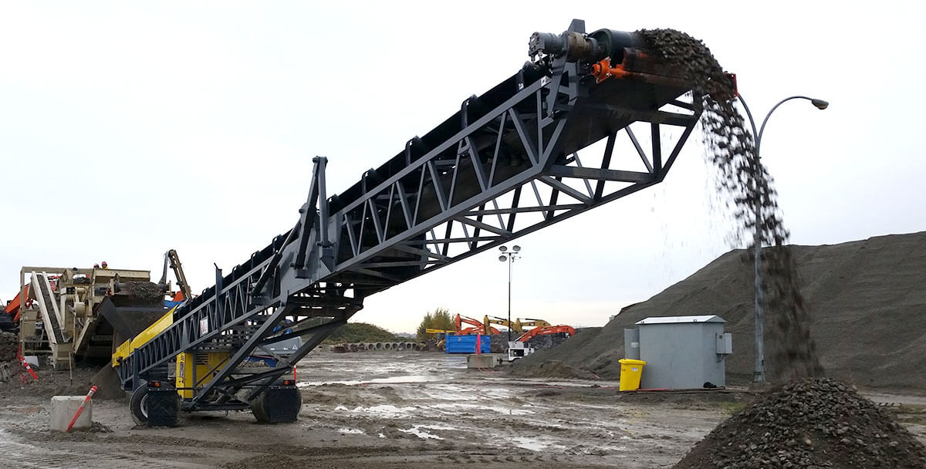

Concept 3: Bucket Elevator Conveyor
- Description: Utilizing a series of buckets attached to a rotating belt to lift and deposit gravel directly into the truck bed. This design is geared towards minimizing spillage and maximizing vertical space.
- Advantages: Efficient in vertical lifting, reduce spillage, and can handle large particle sizes.
- Challenges: Higher initial costs and more complex mechanisms requiring rigorous maintenance.
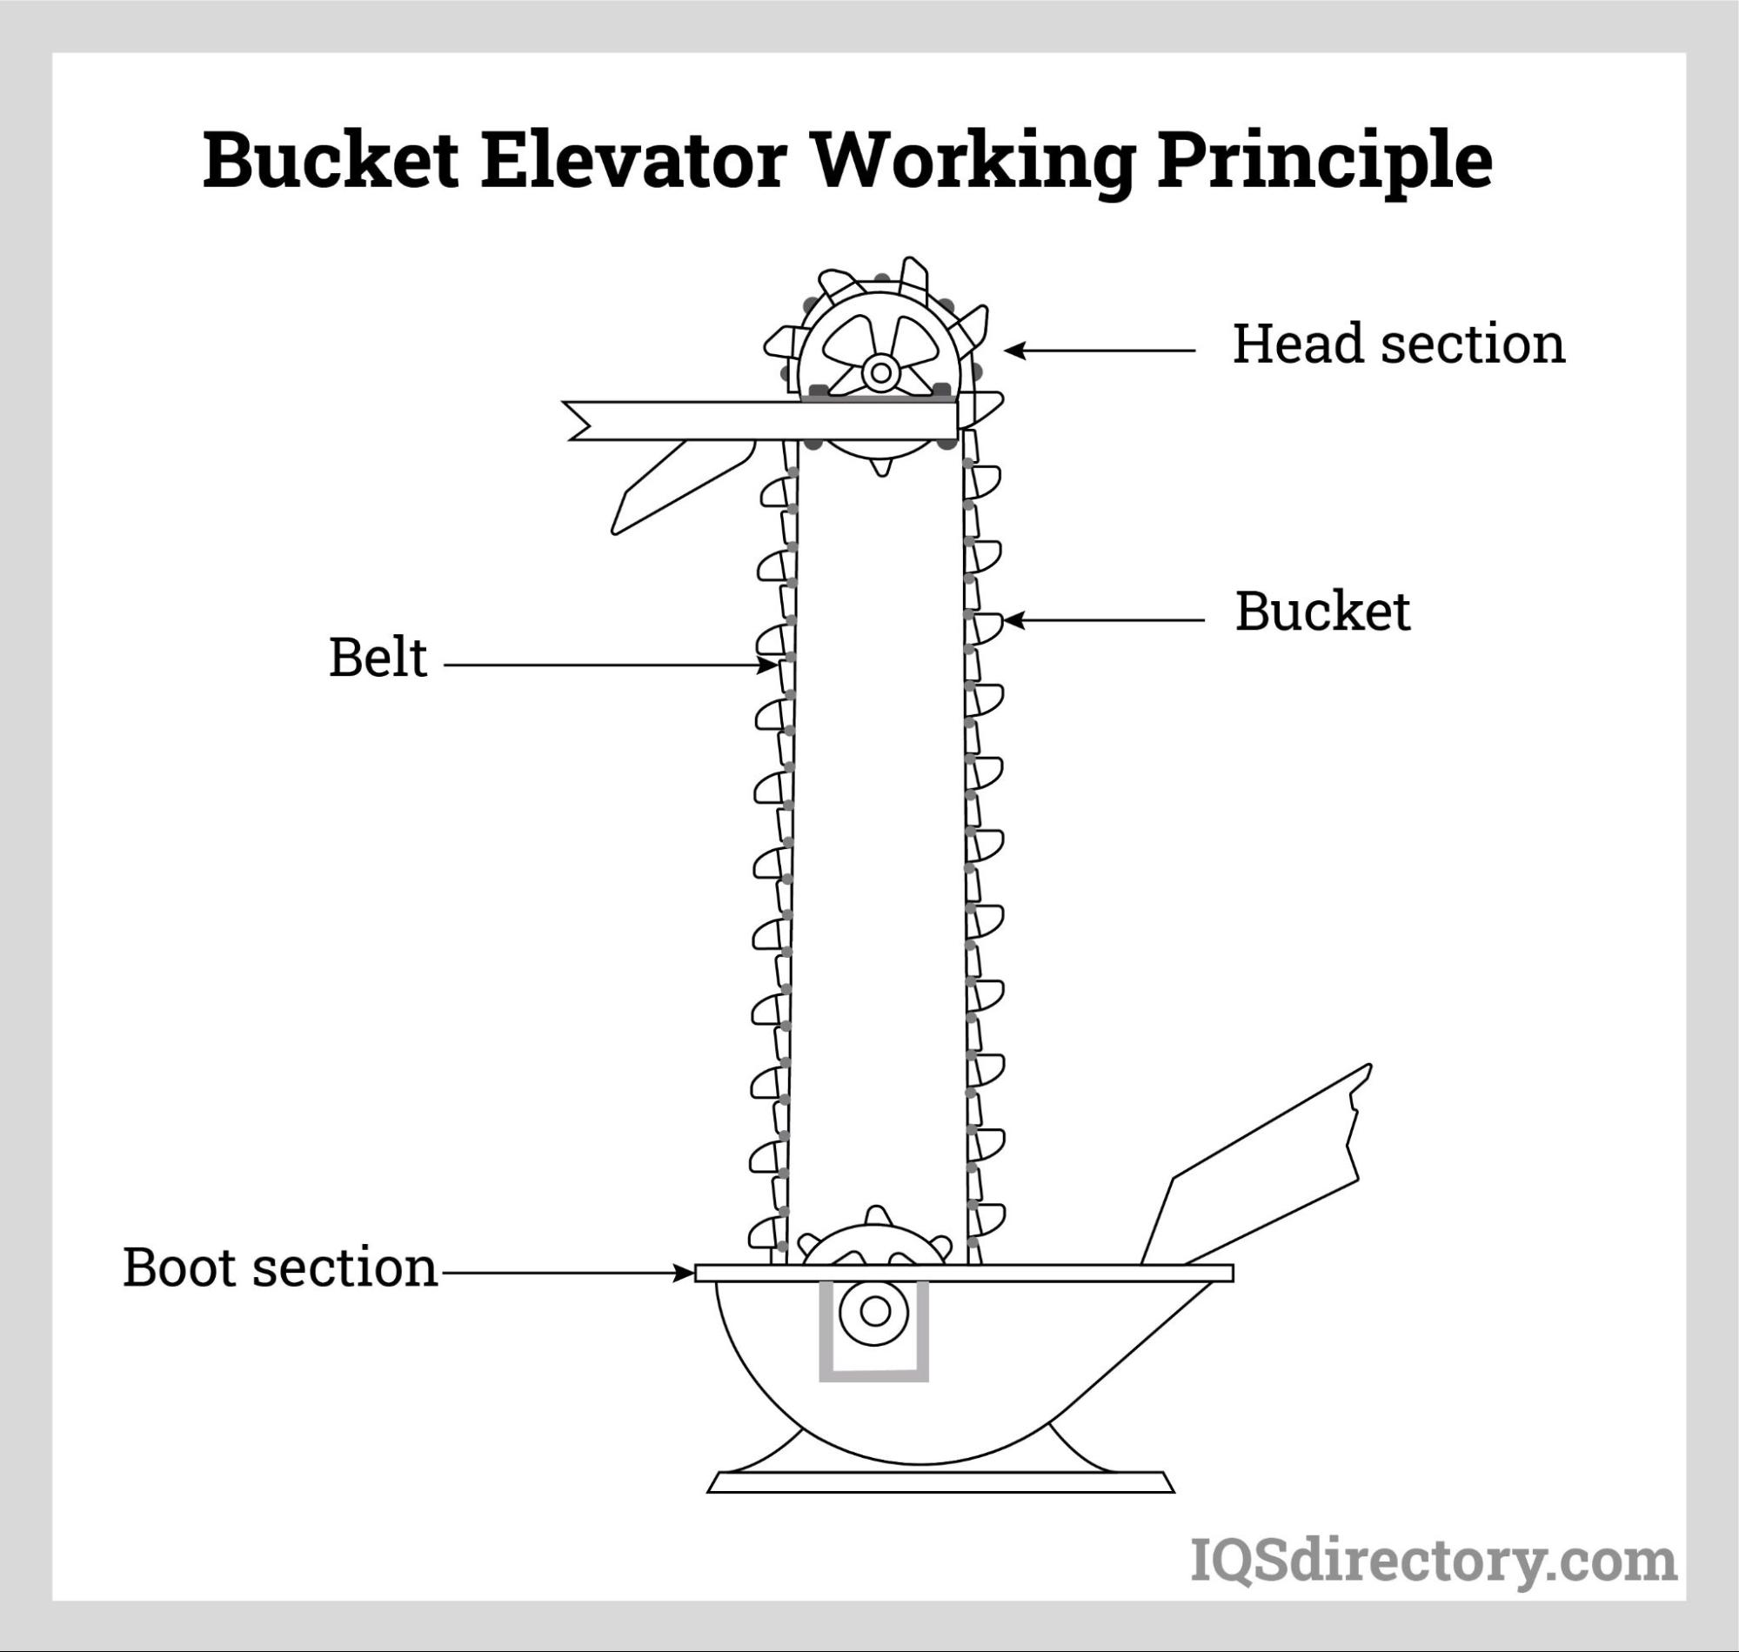

Evaluation of Preliminary Concepts
Each concept will undergo a detailed evaluation based on the following criteria:
- Feasibility: Assess the practicality of implementing each design in a real-world construction environment.
- Cost-Effectiveness: Estimate the total cost of ownership, including initial investment, maintenance, and operational costs.
- Performance: Evaluate the efficiency and reliability of each system under varying operational conditions.
- Safety: Determine the safety level of each concept, ensuring minimal risk to operators and surrounding infrastructure.
These preliminary concepts will be further refined through team discussions, stakeholder feedback, and additional research during the initial phase of the project. The selected concept will then be developed into a detailed design in subsequent phases.

VI. Timetable

 | Description of Work | Start and End Dates
Phase One | Conceptual Design | October 1 - October 15
Phase Two | Preliminary Design | October 16 - November 15
Phase Three | Critical Design | November 16 - December 5
Final Phase | Final Presentation and Report | December 6 - December 10

VII. Key Personnel
- Yuvraj Ghuman (Mechanical Design & Group Coordination)
- Keenan D’Sena (Project Management)
- Keitaro Bonafe (Mechanical Design)
- Amraz Mangat (Mechanical Design)
- Thanh Nam Tran (Finite Element Analysis and 3D Modeling)

VIII. Evaluation
Progress will be evaluated at the end of each phase by comparing the output with the project goals and objectives. Evaluation will include:
- CAD Model Completeness: Evaluation of design iterations and validation through peer review.
- Performance Testing: Detailed analysis of test data against expected performance metrics such as conveyor speed, load capacity, and stability.
- Adherence to Budget: Regular cost reviews to ensure the project remains within financial constraints.
- Timeliness: Progress will be measured against the planned timetable, with adjustments made as necessary to address unforeseen challenges."

IX. Additional note
The next steps following approval of this proposal will be:
- Finalize the list of required materials and request procurement.
- Confirm access to testing and CAD facilities with project supervisors.
- Schedule team meetings to begin Phase 1 activities by October 1.

